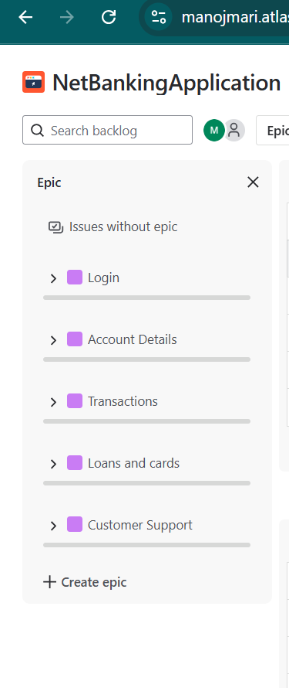

**Sprint 1:**

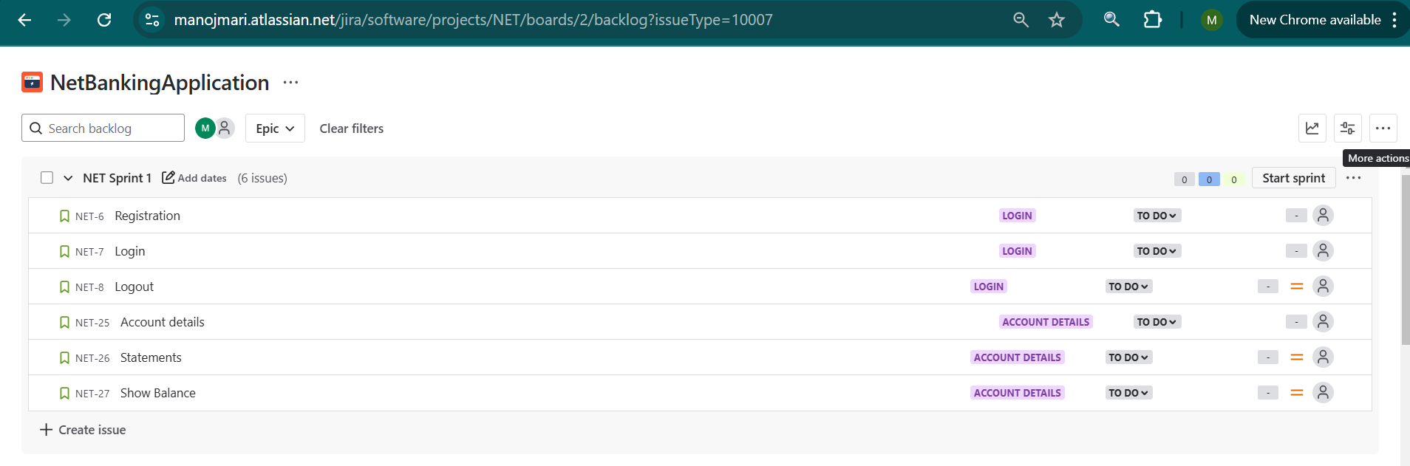

**Sprint2:**

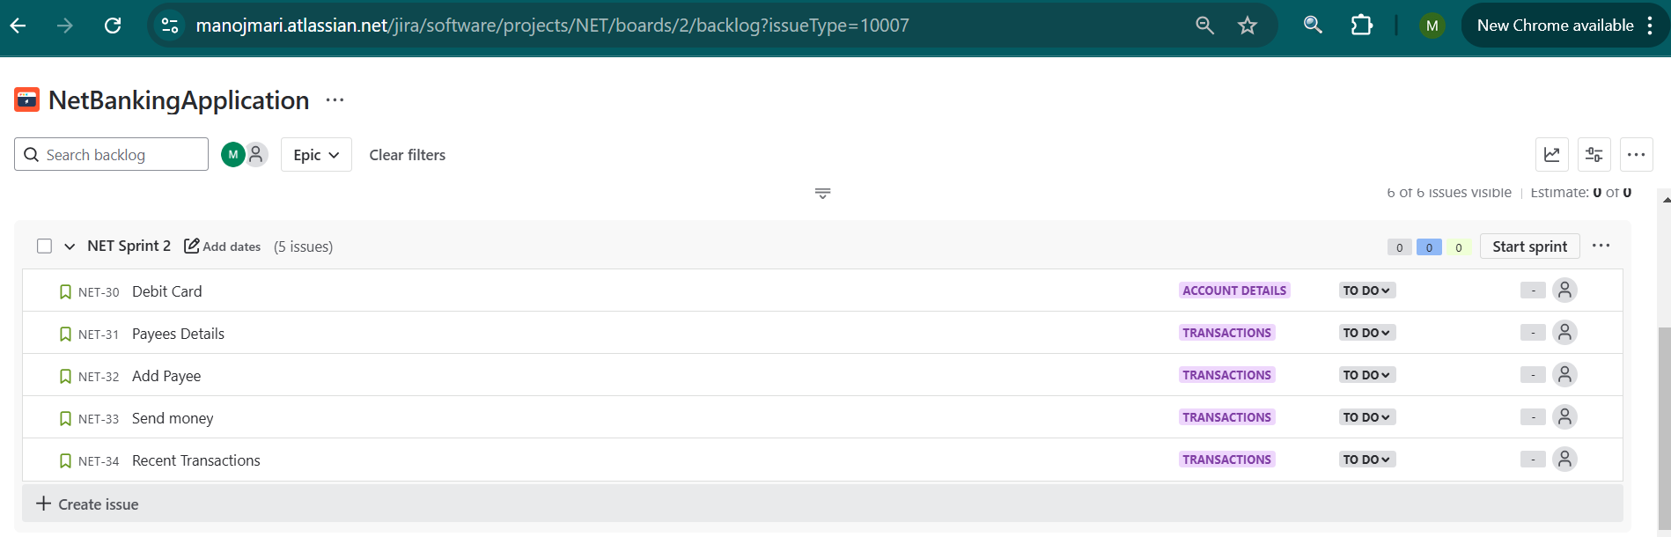

**Sprint 3:**

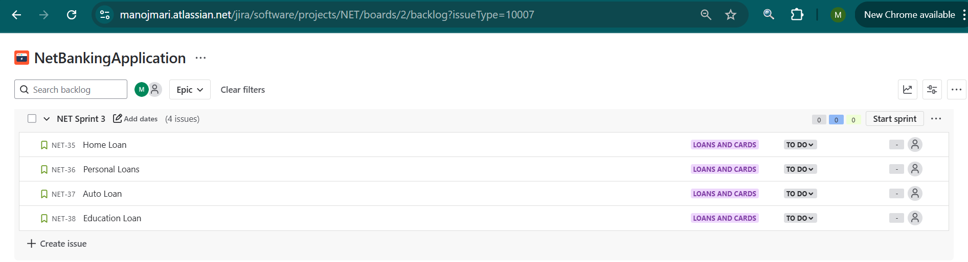

**Sprint 4:**

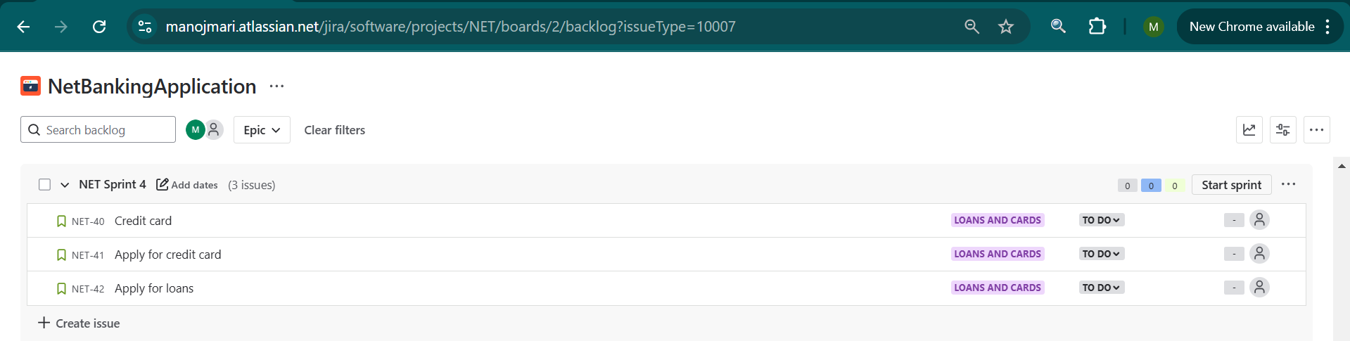

**Sprint 5:**

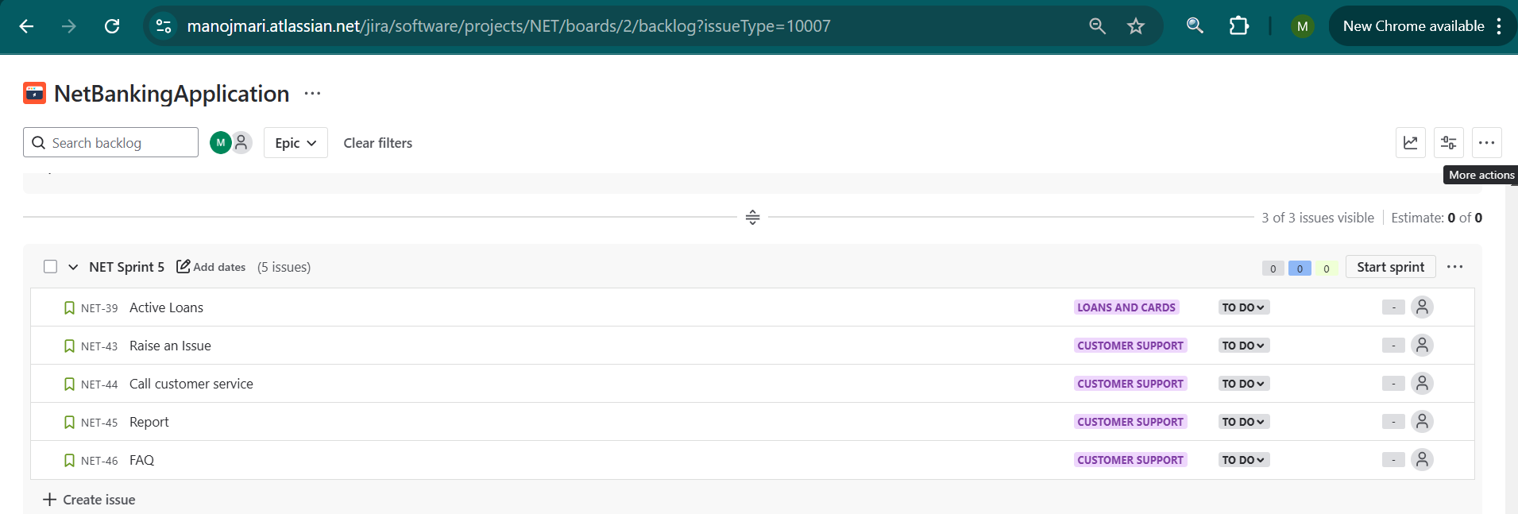

**Sprint 1 – In Progress**

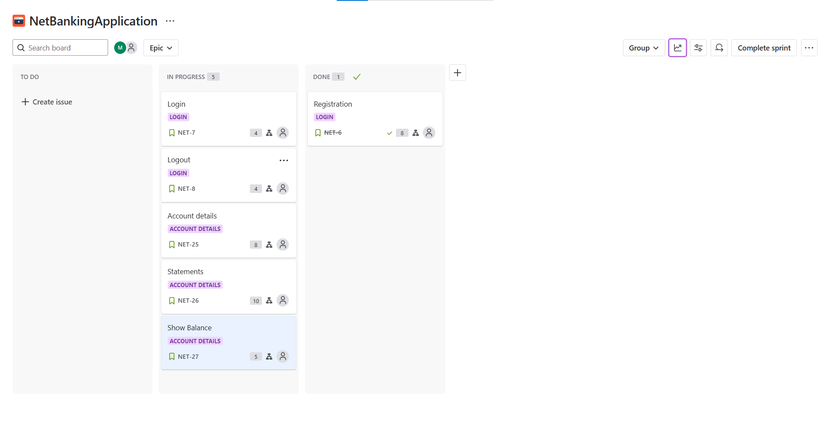

**Sprint 1 – Done**

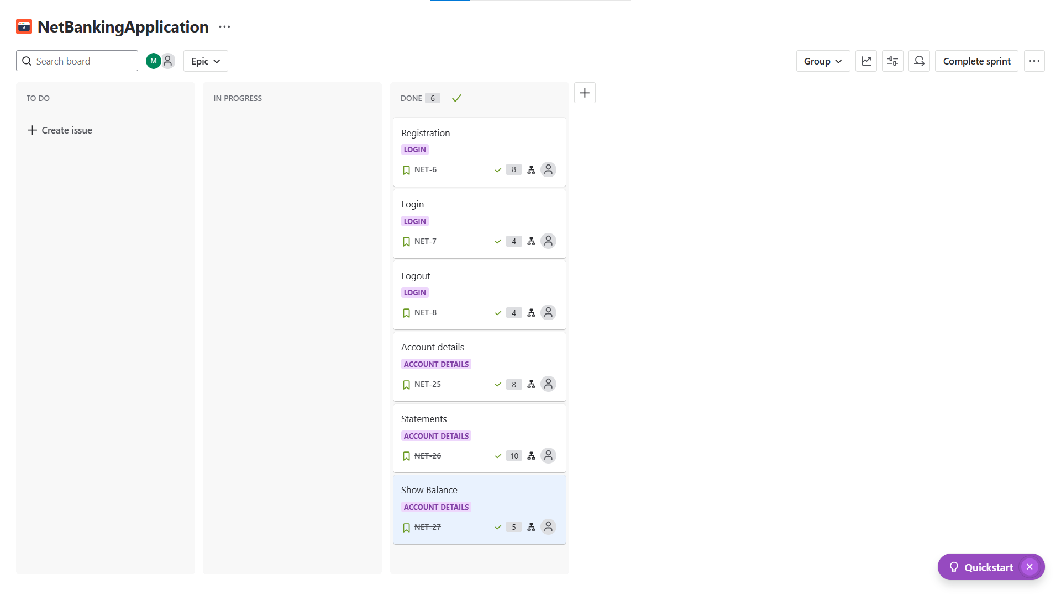

**Sprint 2 – In Progress**

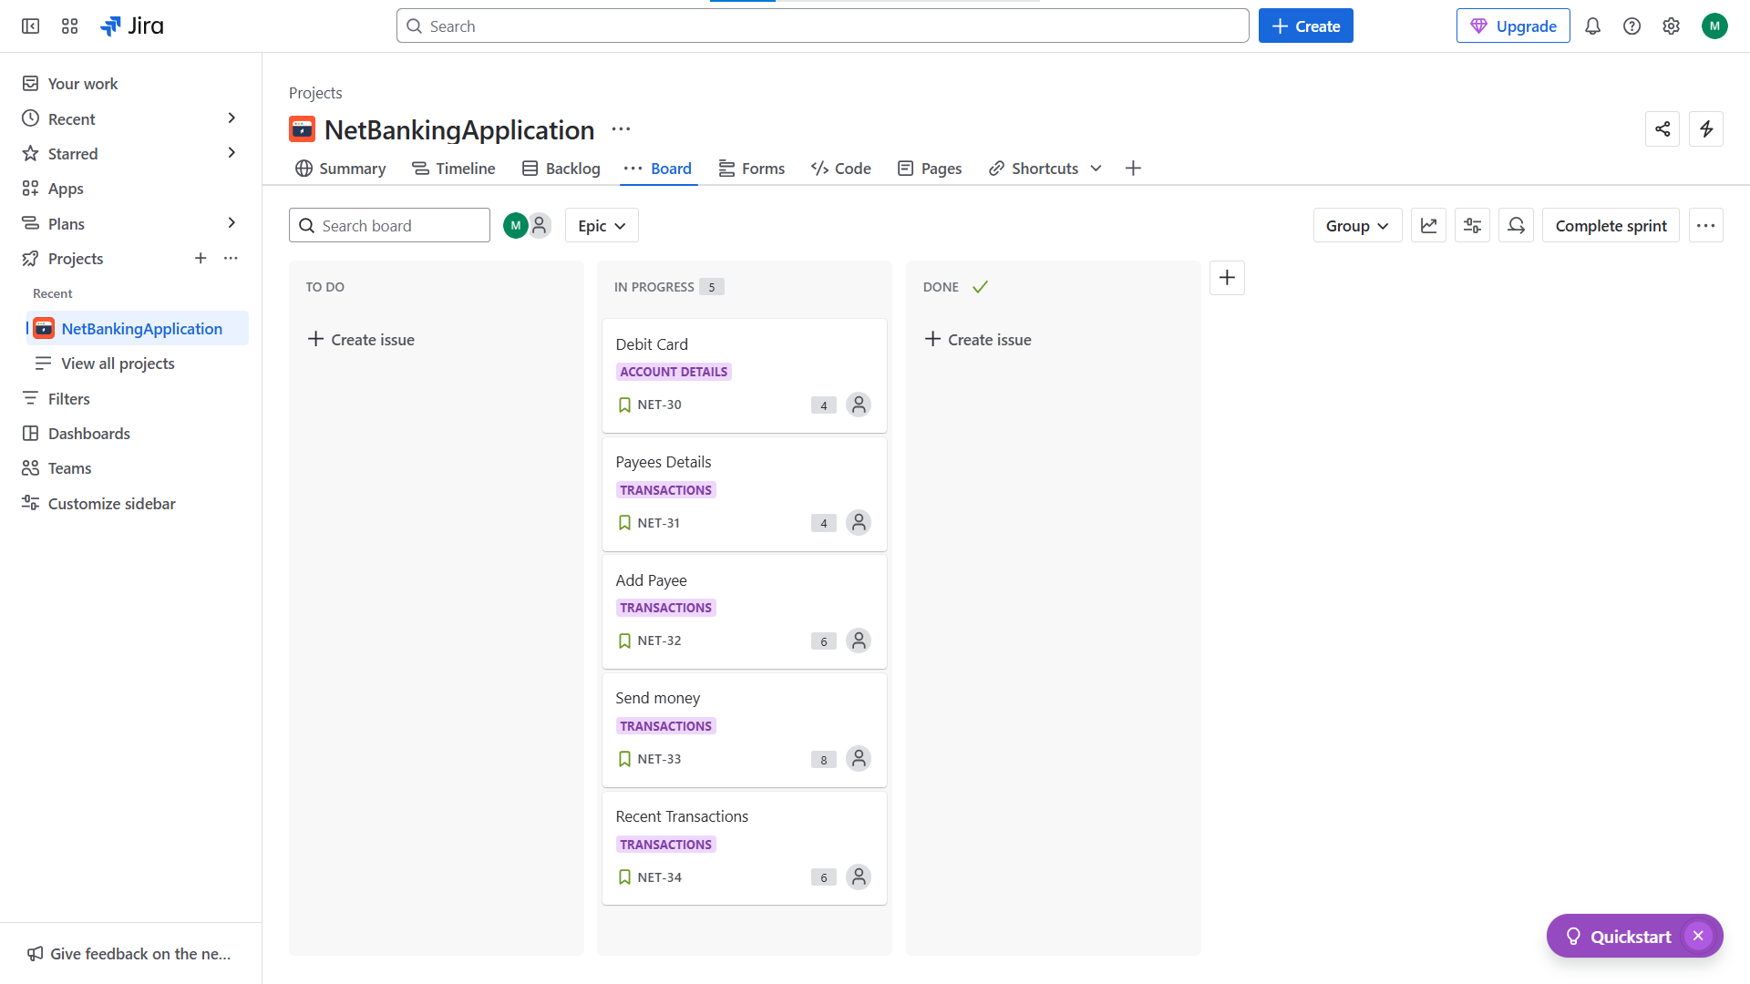

**Sprint 2 – Done**

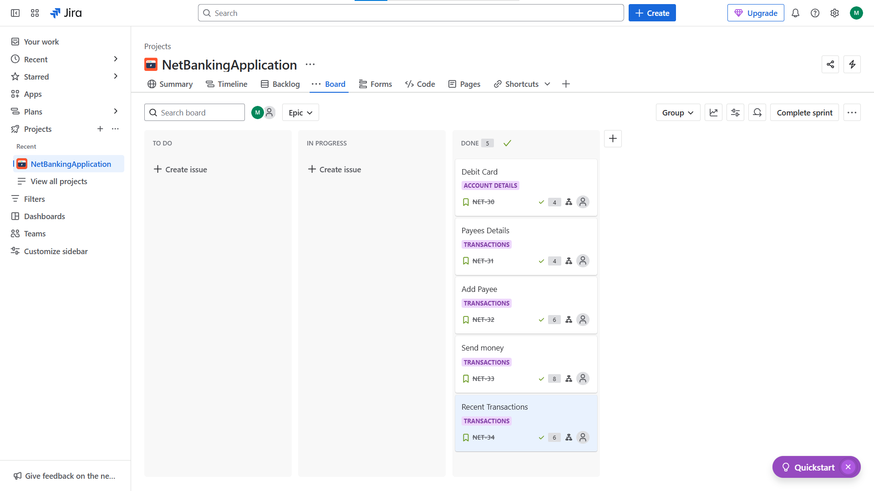

**Sprint 3 – Starting**

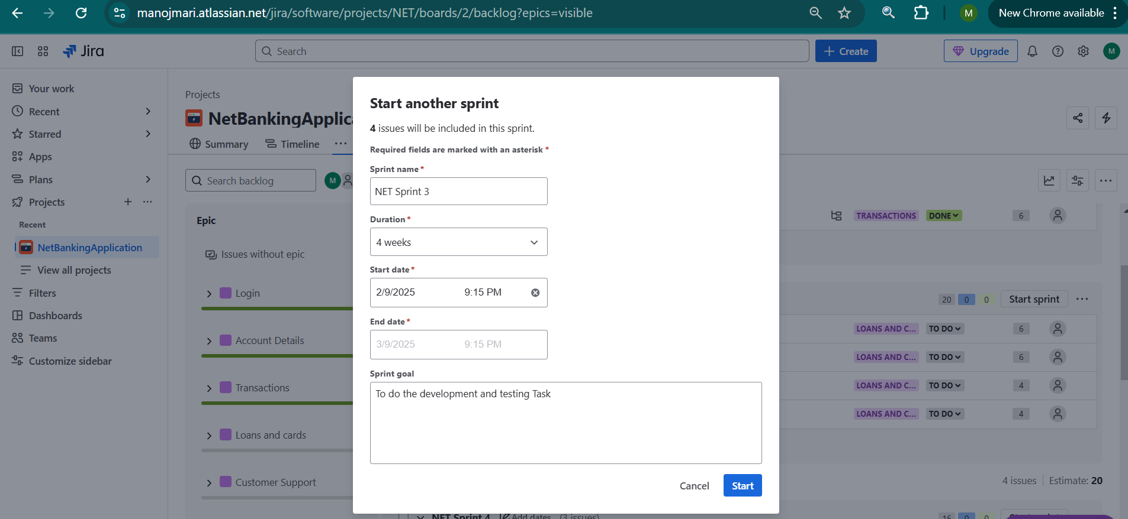

**Sprint 3 – Child Issue creation**

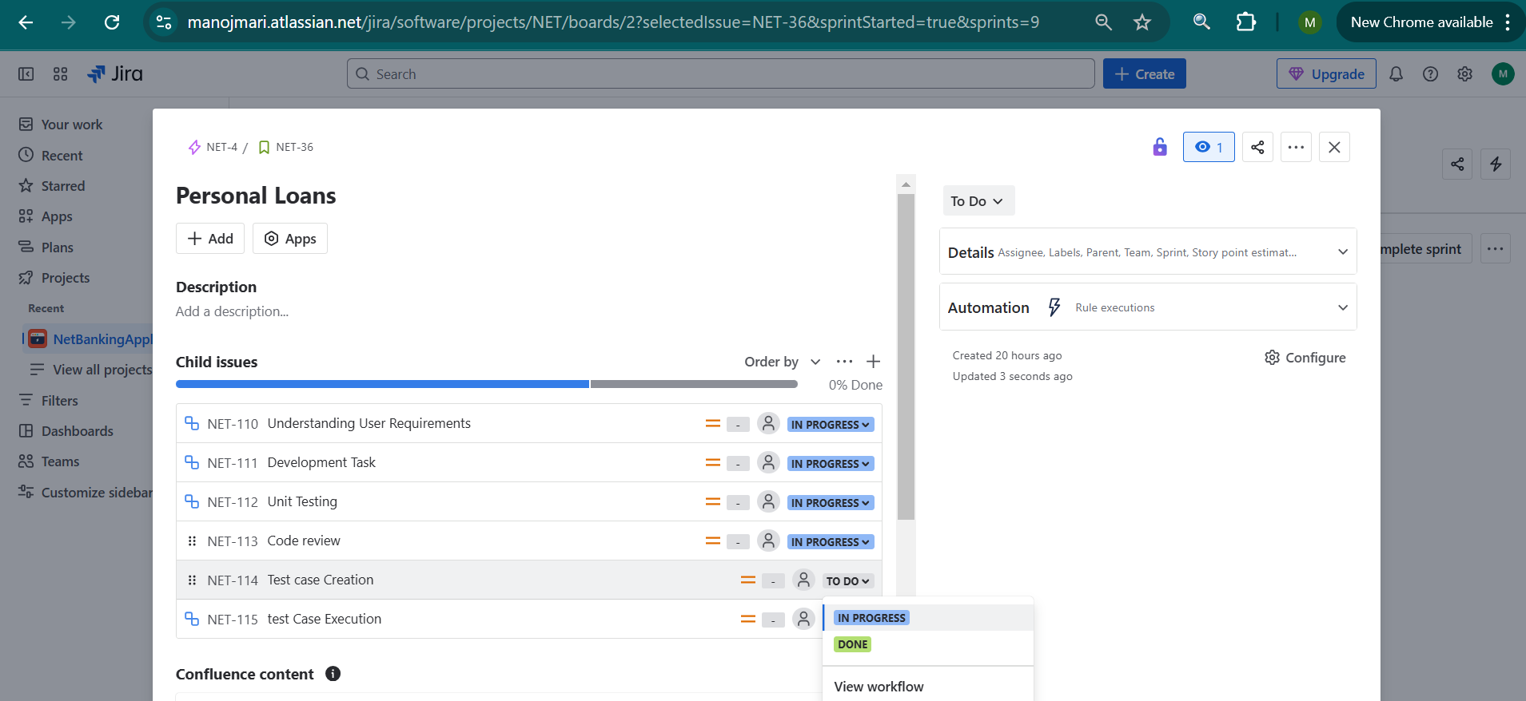

**Sprint 3 – Done**

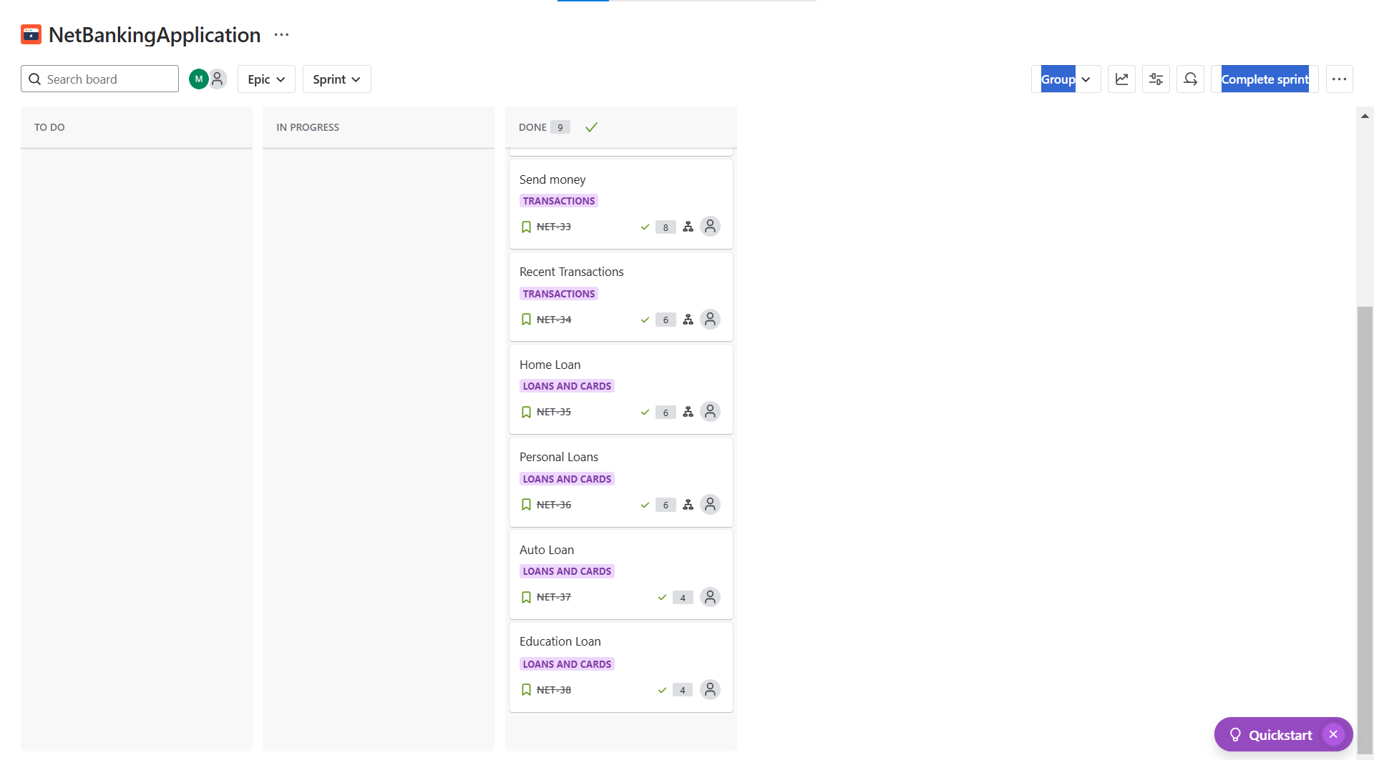

**Sprint 4 – in Progress**

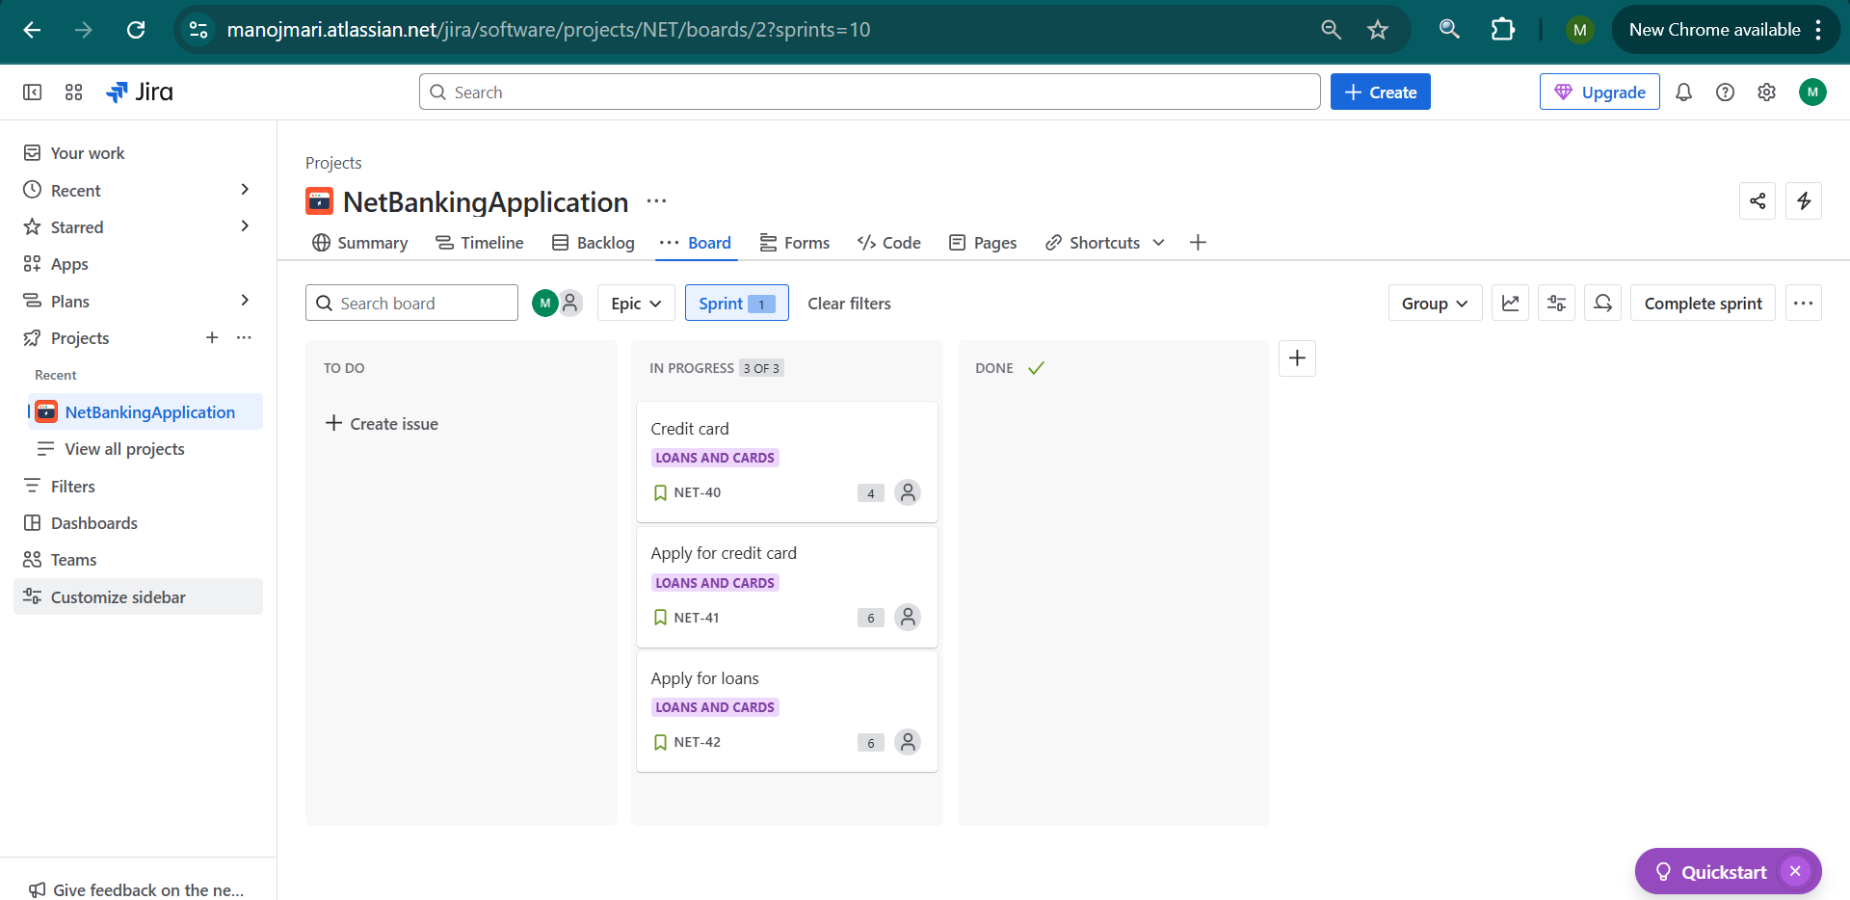

**Sprint 4 - Done**

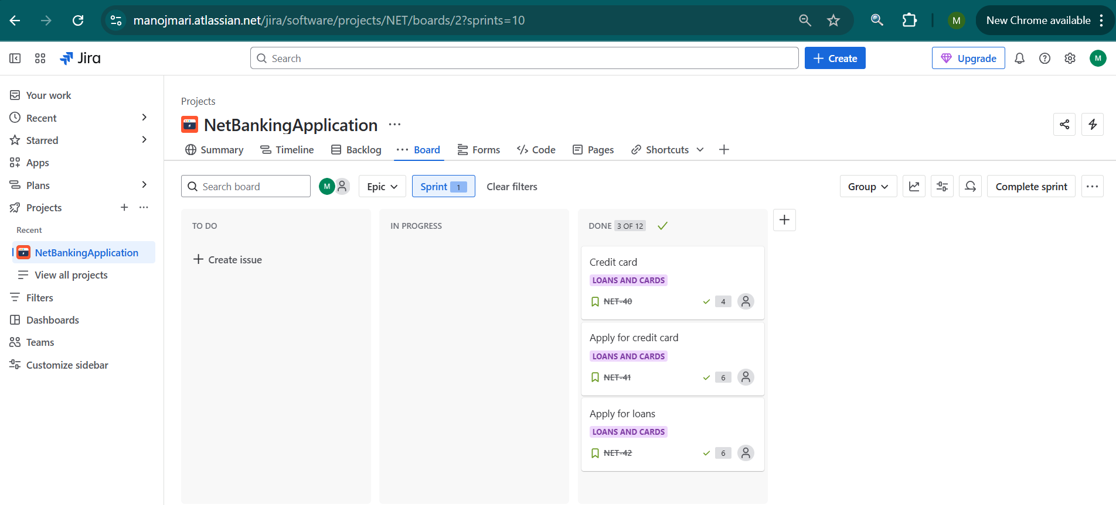

**Sprint 5 – In Progress**

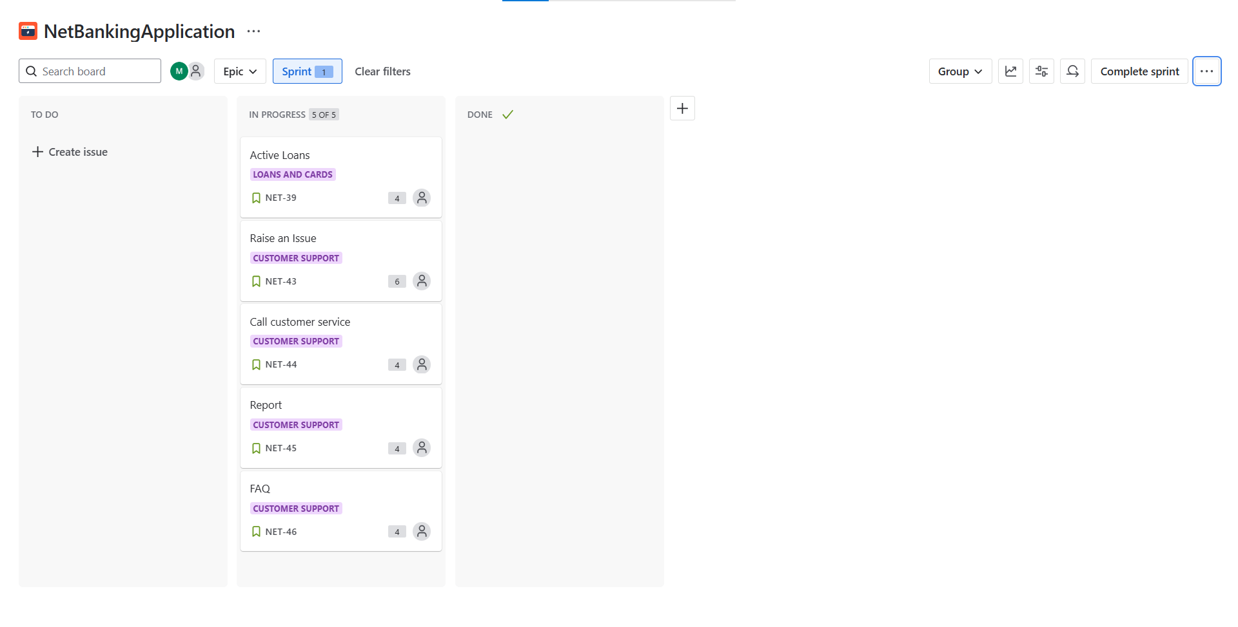

**Sprint 5 – Done**

